**2018/19 S2 – Mini Project Proposal**

**Admin No.** : 1617588

**CA3** 10%

**Name.**  : Shankar   
  
**Module Class**: DEEE/3A/45 **Marks** :

**SECTION ONE – 20%**

A. Proposal Submitted on Time

|  |  |  |
| --- | --- | --- |
|  | **Submitted by 28nd Dec 2018, 5pm (20%)** | **Submitted after 28nd Dec 2018, 5pm (0%)** |
| Proposal Submission |  |  |

**SECTION TWO – 80%**

Application Title: Aglio (A Food Sharing application)

**Project Theme:**

**Samsung – Solve for Tomorrow**

* Environment – propose solutions to address environmental issues that affect the world we live in.

B. Application Description

AGLIO aims to reduce food wastage and enables users to redistribute unsold/excess food to others in Singapore. AGLIO connects neighbours with each other and with local businesses so left-over food can be shared easily anywhere in Singapore. This could be left-over food from festivals, birthday parties or even from restaurants who are willing to donate their food to less the fortunate.

Food waste accounts for about 10 per cent of the total waste generated in Singapore, but only 16 per cent of the food waste is recycled. The rest of it is disposed of at the waste-to-energy (WTE) plants for incineration.

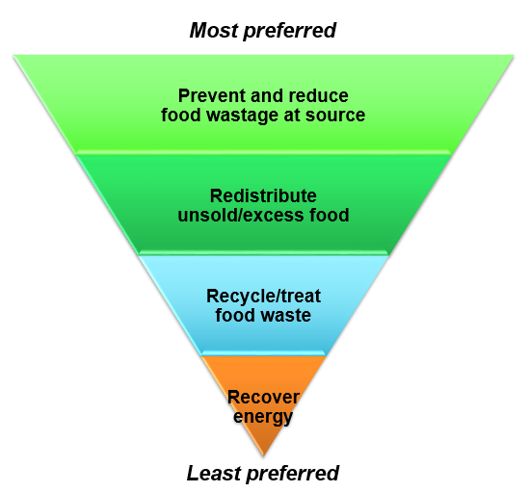

“NEA encourages both organizations and members of the public to donate their unsold and excess food to food distribution organizations” – NEA ([https://www.nea.gov.sg/our-services/waste-management/3r-programmes-and-resources/food-waste-management/food-waste-management-strategies#strategy2](https://www.nea.gov.sg/our-services/waste-management/3r-programmes-and-resources/food-waste-management/food-waste-management-strategies%23strategy2))

AGLIO connects users who are willing to donate food to others, thus playing a meaningful part in reducing food wastage in Singapore. In conclusion, AGLIO is a direct solution to NEA’s (National Environmental Agency) strategy 2 in the Food waste management hierarchy. Through this, I hope we can build a more sustainable future where our most precious resources are shared, not thrown away.

To access items, simply browse the listings available, request whatever takes your fancy and arrange a pick-up via private messaging.

The detailed application guide is given in the next section:

1. Splash Screen with music



Splash Screen

1. AGLIO lists all food items available from the Firebase database once the user enters the app.

* The user is greeted with a main activity screen.
* The user can press the menu option to sort the food items according to the expiry date.
* The user can press the ADD (+) button to add food and it will be updated in the firebase database and to the home screen too.

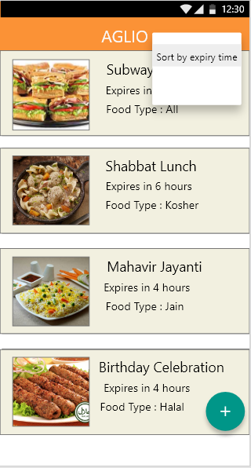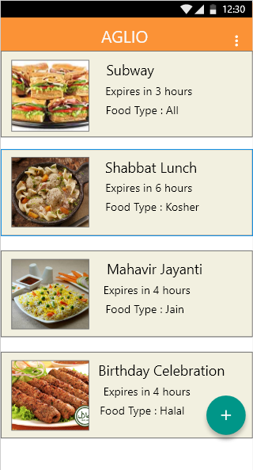

The list is sorted by the expiry time

Menu Option

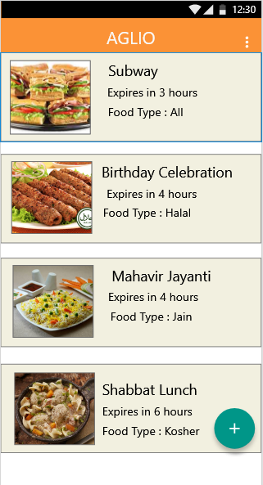

The food list has been sorted out

1. The user can enter his/her details in the app if he/she has left over food. The detail form is shown once the user presses the dark green colour add button as shown below. In this page, the user will enter all his/her data and will be updated in the real time firebase database.

* If the user enters incorrect information , he/she can clear the text in the fields and write over a new text.
* The user can upload a photo taken by a camera to display the food to the other users of the application.
* A submit button is provided so that the data can be uploaded to real time firebase database and the main activity screen can be updated for all users.

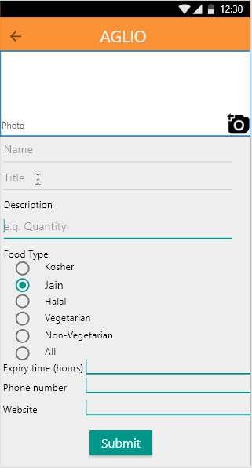

Add in the expiry time

Add phone number so that the other person could communicate

Add a website

Add a picture of the food using built-in camera.

Add in the name of the user who wishes to donate food.

Add in Title

Add in Description

1. From the Food List View, the user can select any of the food cards. After selecting the food card, the user can view the details as shown below.

* In this activity screen, the user can have a full detailed view by clicking on the food card.
* The user can share the food listing to other social media platforms via the share button provided.
* The user can call via the phone number. It uses intents to open a phone application in the android phone.
* The user can also visit the website by clicking on the link

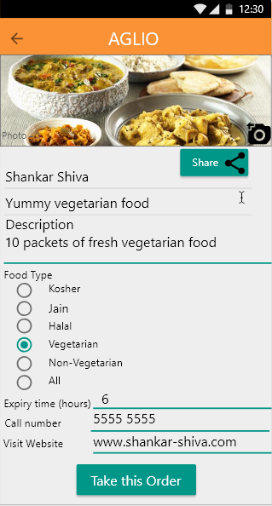

Visit the web site using web view

Call the number using built in call application

View the Title of the food

View the Description of the food

Share in Social Media

C. What makes the application compelling

Food waste is one of the biggest problems facing mankind today.

Between 33-50% of all food produced globally is never eaten, and the value of this wasted food is worth over $1 trillion. Food waste is a huge market inefficiency.

Food waste is damaging for the environment. According to Fact Sheet “It takes a land mass larger than China to grow the food each year that is ultimately never eaten” This is all produced the food that we then just throw away. In addition, food that is never eaten accounts for 25% of all fresh water consumption globally.

The resources that went into creating the uneaten food wasted such as land, water, labour, energy, manufacturing and packaging. All these wasted food ends up in a landfill which created methane because it decomposes without oxygen. Methane is more hazardous than Carbon Dioxide.

Thus, environment conscious people will find this Aglio application useful and compelling.

D. Target Market Segment

The age group is targeted at everyone. The end users can be anyone who is environmentally conscious and wants to be part of saving the environment and make a difference in saving the environment. This application can be used by restaurant owners too.

E. Technical Aspects

Aglio Food Share application uses real time Firebase database to store all listings of leftover food which is updated constantly in real time. The listings can be sorted according to the expiry time of the food.

Main Activity Screen



When the user first opens Aglio, he/she is greeted by a splash screen with music using the Media player. Then, the user can access the food cards in the main activity screen as shown above. The user can also sort the food cards according to the expiry date. If the user has pressed a food card the user will be greeted with another screen as shown below. Here, the user can call the phone number using intents which opens another phone calling application. The phone number is dynamic. The data is updated constantly using the real time firebase database. The user can also view the web link using Web View as shown below. The user can also share the food card by clicking the share button which uses social media API. Once the user presses the “Take this Order” button, the food card is removed from the real time firebase database.

Example Food Card



If the user wants to share the food to others, he/she can press the add button to add a new entry in the real time firebase database. In this screen as shown below, the user can enter all the details including a photo of the food using the Camera. After the user has entered the required details, he/she can press the Submit button to update the real time firebase database.

Add Food Card Activity Screen



APPENDIX

Technical Aspects

1. Basic UIs – 05% 🗹
2. Splash Screen Only – 05% ⬜
3. Using Explicit/Implicit Intent – 05% 🗹
4. Using Telephony – 05% 🗹

(Call using app with dynamic phone number

e.g. from contacts and database etc. Explicit telephone number

entry is not counted)

1. Using Telephony (receive using app) – 05% ⬜
2. Using Media Player (play music) – 05% 🗹
3. Using Social Media (Google API) – 05% 🗹
4. Using Text-to-Speech – 05% ⬜
5. Using SMS (send & receive using app) – 10% ⬜
6. Using Broadcast Receiver for Multiple Alarm – 10% ⬜

(Allow to set more than one alarm time the same time)

1. Using Splash Screen with music – 10% 🗹

or with Text-to-Speech

1. Using Web View with dynamic link – 10% 🗹
2. Using Speech-to-Text – 10% ⬜
3. Using SQLite – 10% ⬜

(Create own data structure - Read/Write/Delete; 5% for no Delete)

1. Using Custom Broadcast Receiver – 15% ⬜

(i.e. built-in system Broadcast Receiver not counted)

1. Using Service – 15% ⬜  
   (playing music at background not counted)
2. Using Local Phone book (Read/Write/Delete) – 15% ⬜
3. Using Local Phone Calendar (Read/Write/Delete) – 15% ⬜
4. Using XML/JSON Parsing – 15% ⬜

(Using Firebase API calls not counted)

1. Using Accelerometer – 15% ⬜
2. Using Compass – 15% ⬜  
   (must be incorporated into map i.e. map will rotate whenever phone rotates)
3. Using 2D Graphic (Use of graphic function calls) – 15% ⬜
4. Using Bluetooth Connection – 15% ⬜
5. Using Camera (Read/Write/Delete) – 15% 🗹
6. Using Face Detector – 15% ⬜
7. Using Client/Server (send & receive) e.g. Firebase – 15% 🗹
8. Using Barcode/QR Scanning (read & save data) – 15% ⬜
9. Using Google Geofencing – 15% ⬜
10. Augmented Reality(AR)/Artificial Intelligence(AI) – 15% ⬜

-END-